**Thomas Martin**

**CS-340-11221-M01 Client/Server Development 2024**

**5-1 Project One Submission**

**Southern New Hampshire University**

**June 07, 2024**

1. Upload the Austin Animal Center Outcomes data set into MongoDB by inserting a CSV file using the appropriate MongoDB import tool. The data set is located in the Supporting Materials section. Complete the import using the mongo import tool, and take screenshots of both the import command and its execution. You will include these screenshots in your README file later.  
Note: If you completed the Module Three Milestone, you have already completed this step. Be sure to include your screenshots from the Module Three Milestone in your README file.

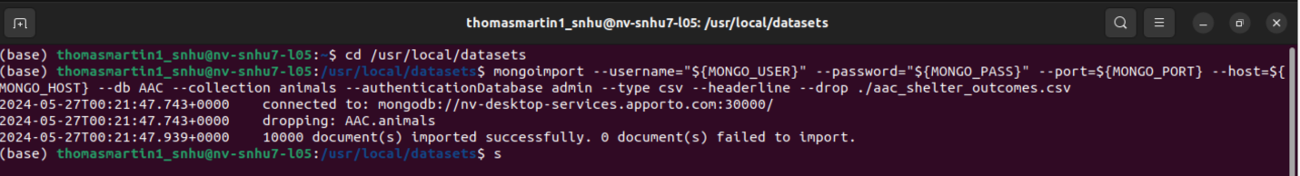

2. Create a user account in the mongo shell to ensure user authentication to the database and collection you created. Be sure to take a screenshot of the mongo shell execution command screen that shows your login process. You will include this screenshot in your README file later.  
Note: If you completed the Module Three Milestone, you have already completed this step. Be sure to include your screenshots from the Module Three Milestone in your README file.

Next, you must develop a Python module in a PY file, using object-oriented programming methodology, to enable CRUD functionality for the database. Other Python scripts must be able to import your Python code, so it must support code reusability.  
Develop a CRUD class that, when instantiated, provides the following functionality:

A Create method that inserts a document into a specified MongoDB database and collection

Input -> argument to function should be the key/value lookup pair to use with the MongoDB driver find API call.

Return -> “True” if successful insert, else “False”.

A Read method that queries for document(s) from a specified MongoDB database and specified collection

Input -> arguments to function should be the key/value lookup pair to use with the MongoDB driver find API call.

Return -> result in a list if the command is successful, else an empty list.  
Important: Be sure to use find() instead of find_one() when developing your method. Hint: You will have to work with the MongoDB cursor returned by the find() method.

An Update method that queries for and changes document(s) from a specified MongoDB database and specified collection

Input -> arguments to function should be the key/value lookup pair to use with the MongoDB driver Find API call. The last argument to function will be a set of key/value pairs in the data type acceptable to the MongoDB driver update_one() or update_many() API call.

Return -> The number of objects modified in the collection.

A Delete method that queries for and removes document(s) from a specified MongoDB database and specified collection

Input -> arguments to function should be the key/value lookup pair to use with the MongoDB driver find API call.

Return -> The number of objects removed from the collection.

Finally, you must test your Python module to make sure it works. To do this testing, create a Python script that imports your CRUD Python module to call and test all instances of CRUD functionality. Be sure to create this script in a separate Jupyter Notebook (IPYNB) file and import and instantiate an object from your CRUD library to effect changes in MongoDB. Be sure to use the username and password for the “aacuser” account for authentication when instantiating the class. After creating your script, execute it in Jupyter Notebook and take screenshots of the commands and their execution. You will include these screenshots in your README file later.

